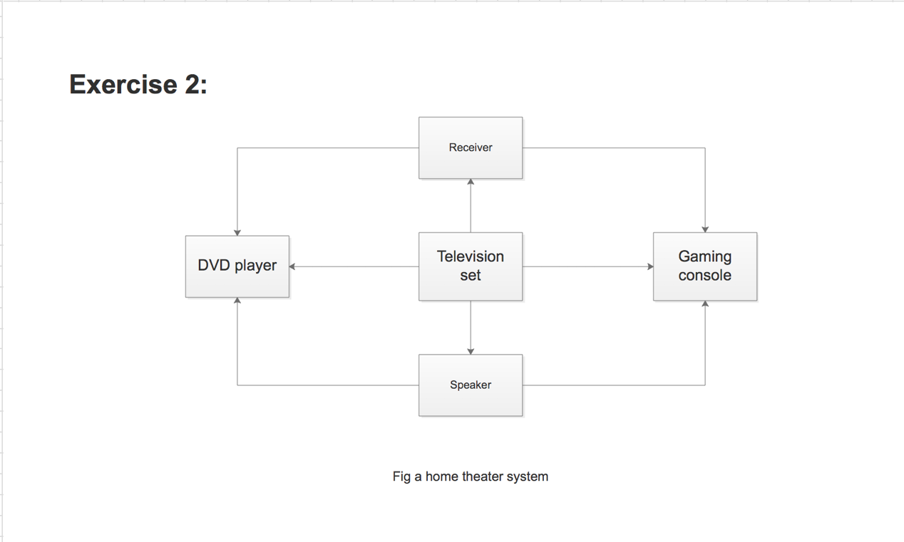

Input: DVD, digital signal.

output: Voice, picture, module signal.

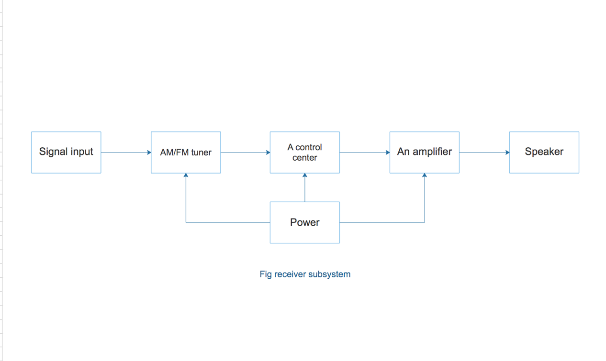

Input: digital signal, DVD or gaming card.

Output: module signal (after amplifying).

These inputs and outputs has confirmed to the links connected to the receiver in my system diagram.